**The Title of the Abstract Should be Written in Arial, Bold 13pt, Centered. Initial Letter of Each Word Should be Capitalized**

**Presenting Author**,1,2 Other Author,1 Other Author,2 and Corresponding Author1,*

1Affiliation, City, Zip Code, Country

2Affiliation, City, Zip Code, Country

Email: correspondence-email@xxxx.xx

This is the instruction for preparation of abstract. It also serves as the template for the page layout. Do not change any settings, otherwise your abstract might show in the conference book of abstracts incorrectly.

Abstracts should be written in English and submitted both in the one page camera-ready, MS Word format.docx template and an unprotected PDF file generated from it.

Title of the abstract should be centered and typed in Arial, bold 13-point font. Capitalize the first letter of each word of the tide other than prepositions, conjunctions

and articles. All authors should be listed followed by their affiliations; department/institution,

city, country of all authors. Use numbers to indicate the different affiliations of the authors. Underline the name of the presenting author in bold type. Mark the corresponding author with

an asterisk (*). The author list and author affiliation list should be centered. Leave one empty line between the authors and the body of the abstract. The abstract should fit on one page, according to this template single-spaced with 11-point font Arial.

Figures should be centered. Each figure should have a brief caption describing it, and die caption should be placed below (or next to) the figure in 10-point font. Be sure that figures also fit on the one page for the abstract. Cite references in the text with a superscript number in brackets (e.g. [1] or [1-6]), numbers after punctuation marks. Number all references sequentially as they appear in the text, starting with [1]. Make all references complete bibliographic citations in the style below.

All abstracts should be submitted electronically by the deadline shown for the abstract submission on the web page <https://www.omcos2019.de/> as described there. Any inquiries regarding abstract submission should be directed to the OMCOS 20 Conference Team at:

[unikt-kongresse@zuv.uni-heidelberg.de](mailto:unikt-kongresse@zuv.uni-heidelberg.de)

Please do not modify the format of this abstract.

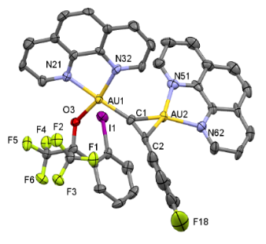Figure 1. Alkynylgold(III) complex.

**References**[1] a) K. Sekine, *Gold Bull.* **2017**, *50*, 203-209; b) M. Zhang, X.‐A. Yuan, C. Zhu, J. Xie, *Angew. Chem. Int. Ed.* **2019**, *58*, 312-316.

[2] B. Zhang, T. Wang, *Asian J. Org. Chem.* **2018**, *7*, 1758-1783.

[3] J. E. M. N. Klein, D. Mandal, W.-M. Ching, D. Mallick, L. Que, S. Shaik, *J. Am. Chem. Soc.* **2017**, *139*, 18705-18713.

[4] J. Messelberger, A. Grunwald, P. Pinter, M. M. Hansmann, D. Munz, *Chem. Sci.* **2018**, *9*, 6107-6117.

[5] J. Vaitla, A. Bayer, *Synthesis* **2019**, *51*, 612-628.

[6] A. Ramaraj, M. Nethaji, B. R. Jagirdar, *J. Organomet. Chem.*, doi: 10.1016/j.jorganchem.2018.12.017